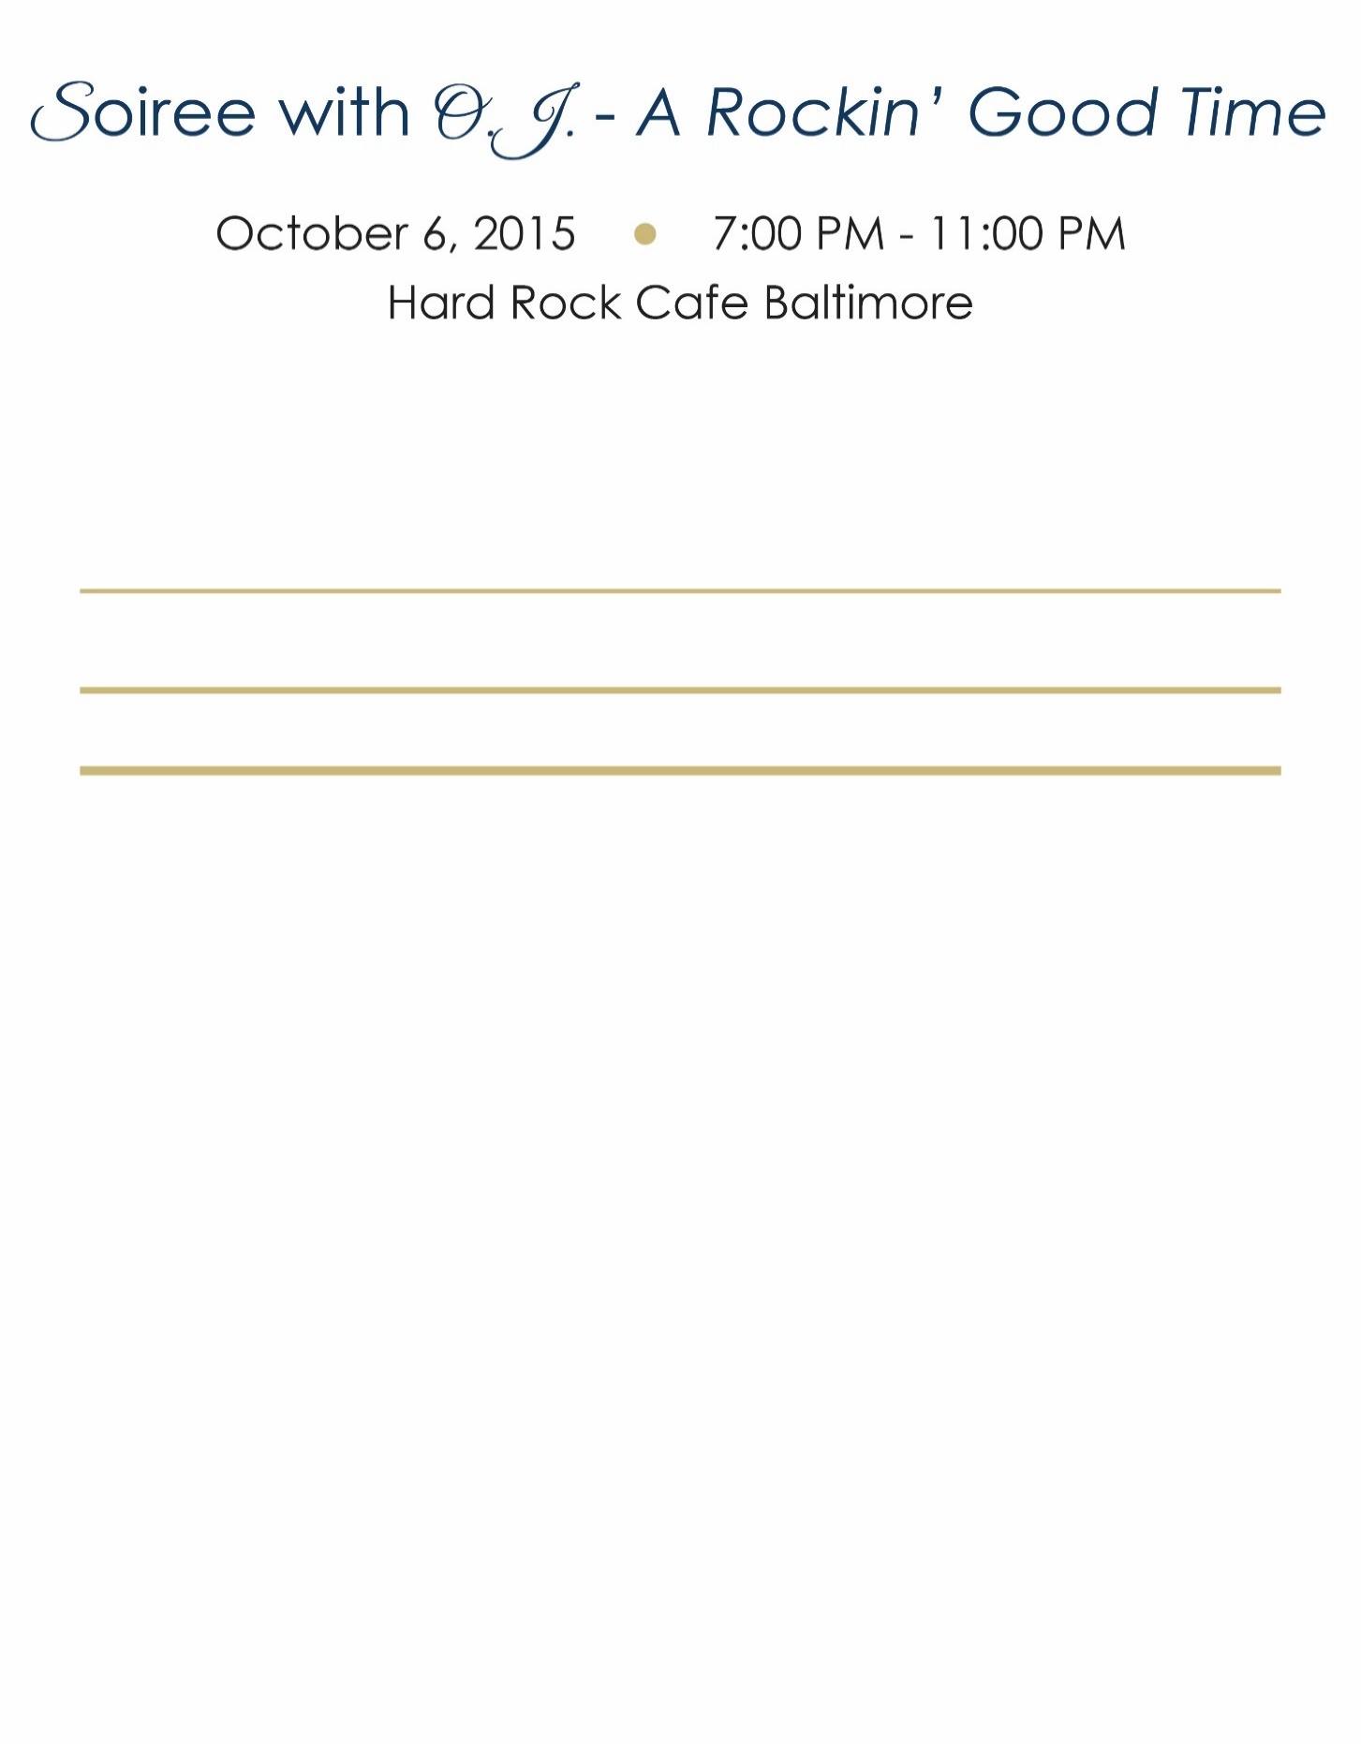***Senior Dogs Rock!***

NATIONAL ONLINE AUCTION SPONSOR

The Grey Muzzle Organization invites you to support our lifesaving work on behalf of senior dogs. Our unique, national peer reviewed grant program, made possible by our supporters, helps shelters and rescue organizations provide vital veterinary and dental care and secure loving forever homes so that every senior dog thrives and no old dog dies alone and afraid. Senior dogs have so much love to give; please join us in giving these sweet at-risk dogs a second chance!

**Sponsorship Opportunities & Recognition:** Name/Logo and Link to company website to be featured on Grey Muzzle’s Online Auction page (upcoming on www.biddingforgood.org) and our organization’s website, e-newsletter, and social media channels (Facebook, Twitter). Prominence and frequency of recognition is tiered, based on sponsorship level. Please select your support level and email logo to sharon@greymuzzle.org.

**☐ HALL OF FAME … $5,000**

**☐ ROCK STAR………..$2,500**

**☐ V.I.P…………………..$1,000**

**☐ FAN……………………$500**

Individual or Company Name(s):



Primary Contact:



Address:



City: State:  Zip:



Land Line: Mobile:  Email:



**We are pleased to offer our support and become a *“Senior Dogs Rock!”* Auction Sponsor!**

☐My/our contribution check is enclosed. *(Check payable to: The Grey Muzzle Organization)*

☐Please contact me to obtain credit card payment information for my/our contribution.

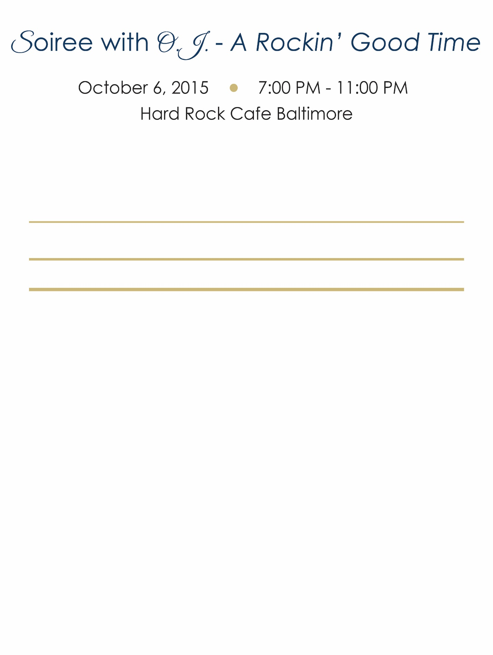

***The Grey Muzzle Organization*** *–* ***www.greymuzzle.org*** *- 14460 Falls of Neuse Road, Suite 149-269, Raleigh, N. C. 27614. Nonprofit EIN: 26-1965495. For additional information, kindly email message to:*  sharon@greymuzzle.org.